Kubernetes :- CKA ( Certified Kubernetes Associates ) – 01/03/2021

<https://carltsuis-blog.readthedocs.io/en/latest/kubernetes/Architecture%20of%20a%20Kubernetes%20cluster/>

Architecture :-

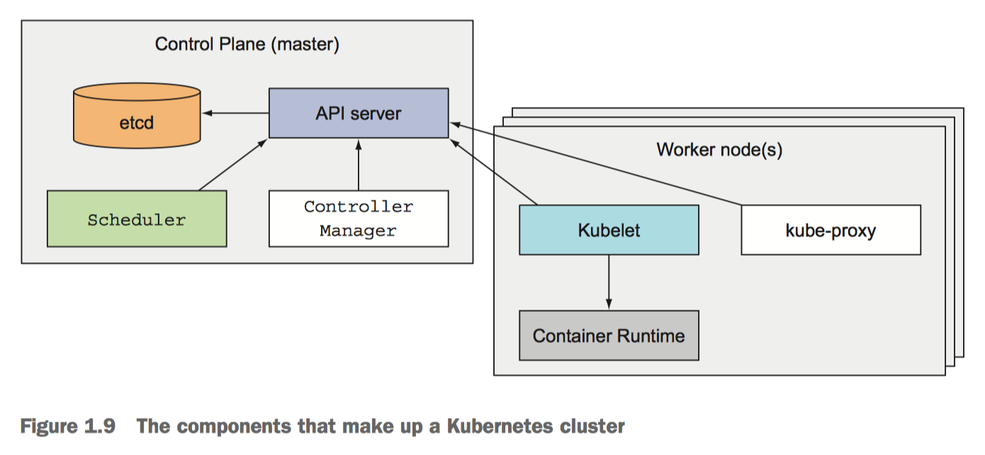

<https://phoenixnap.com/kb/understanding-kubernetes-architecture-diagrams>

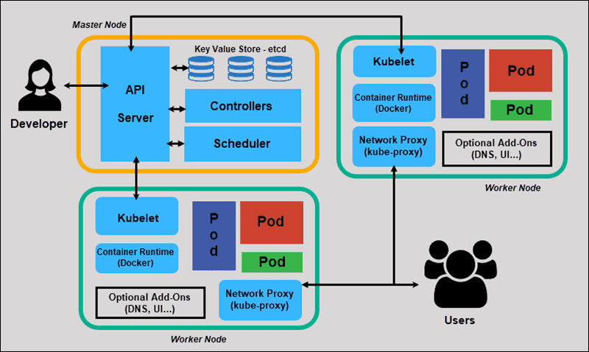

**Kubernetes Master Node:-**

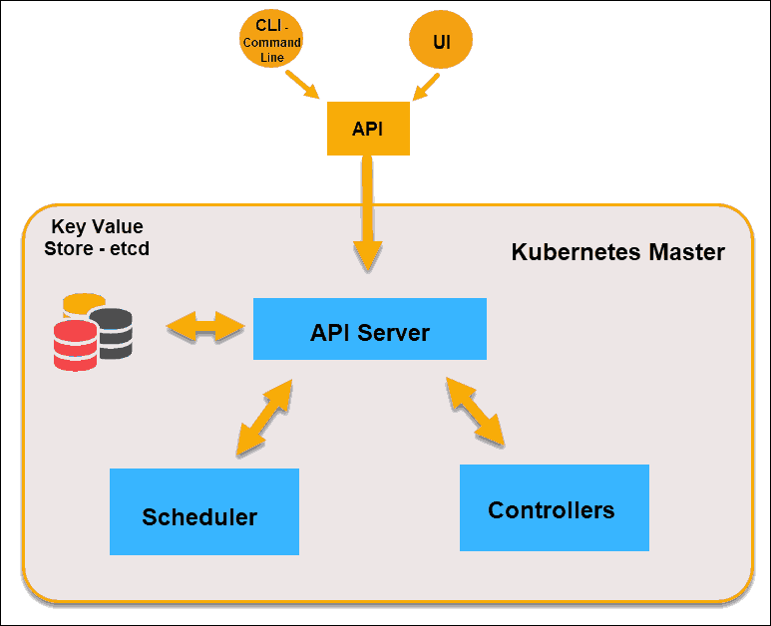

* Hosts the Kubernetes control plane that controls and manages the whole Kubernetes systems
* Receives input from CLI/UI via an API-server
* User defines – Replica, Pods and services

Control Planes :-

* They don’t run any applications
* Controls its cluster and makes it function
* It runs on single master node or multiple to support high availability
* It contains :-
  + **API-Server**: - A user/front-end or other control plane components communicates with
    - Authenticate user
    - Validate request
    - Retrieve Data
    - Update ETCD
    - Scheduler
    - Communicate with kubelet
    - kubectl get pods -n <pod name >
    - ps -ef | grep kube-apiserver – Shows the process
    - /etc/systemd/system/kube-api-server.service – Non – kubeadmin setup
  + **Scheduler** – Schedules the apps. Watches the new request from the API server. It ranks the quality of nodes and deploys pods to the best suited node ( Which pod goes to which node )
    - It goes in two phases – Filter Nodes ( Discard the nodes don’t fit the purpose ) Rank Nodes ( Assign a score as per node and choose the best one )
    - Labels & Selectors
    - Daemon Sets
    - Resource Limits
    - Manual Scheduling
    - Multiple Schedulers
    - Scheduler Events
    - Configure Kubernetes Scheduler
    - Download and Install – from Kubernetes-releases
  + **Control Manager/Controller**: - Used for replicating components, watching worker nodes and handling node failures
    - It monitors the nodes though kube-api-server
    - Node monitor period – 5sec
    - Waits for 40 secs before marking it as dead ( Grace Period )
    - POD eviction time 5 mins
    - All these are packaged in Kube-Controller-Manager
    - Download and install from Kubernetes release
    - kubectl get pods -n <pod name >
    - ps -ef | grep kube-controller-manager – To see the process status
  + **Etcd (Key Value Store)**: -
    - A data storage (database) which stores the cluster configurations (Nodes, Pods, Configs, Secrets, Accounts, Roles, Bindings, etc.)
    - Master node queries etcd to retrieve parameter for the state of nodes, pods and containers
    - Download, Install and Run (./etcd)
    - Listens on port – 2379
    - Default client comes with ETCD is - etcdctl ( etcd control clients ) **[./etcdctl set key1 value1**]
    - To retrieve data run - ./etcdctl get key1
    - Run etcdctl – To get more help options
    - Etcdctl is the CLI tool to interact with ETCD – It has two API versions – V2 (Default) and V3
    - V2 supports following commands
      * etcdctl backup
      * etcdctl cluster-health
      * etcdctl mk
      * etcdctl mkdir
      * etcdctl set
    - V3 supports following commands
      * etcdctl snapshot save
      * etcdctl endpoint health
      * etcdctl get
      * etcdctl put
    - To set the right version of API - export ETCDCTL_API=3
    - ETCD certificates are placed here :
      * --cacert /etc/kubernetes/pki/etcd/ca.crt
      * --cert /etc/kubernetes/pki/etcd/server.crt
      * --key /etc/kubernetes/pki/etcd/server.key
    - User can set-up this by running this :-
      * kubectl exec etcd-master -n kube-system -- sh -c "ETCDCTL_API=3 etcdctl get / --prefix --keys-only --limit=10 --cacert /etc/kubernetes/pki/etcd/ca.crt --cert /etc/kubernetes/pki/etcd/server.crt --key /etc/kubernetes/pki/etcd/server.key"

**Worker Nodes/Nodes :-**

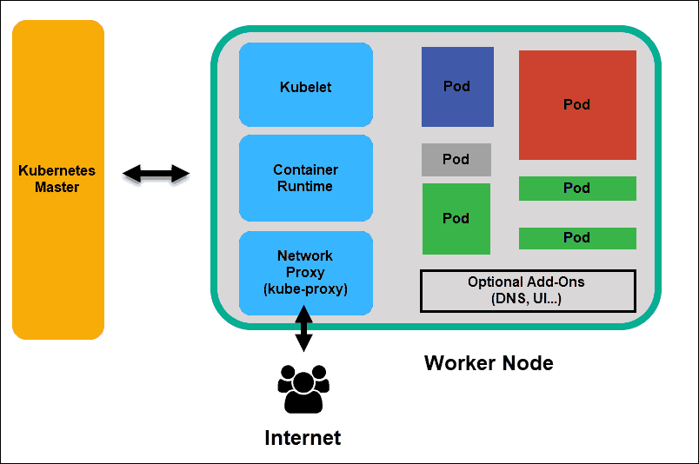

* + Listens to API server for work assignments. Executes the work and report the result back to Master Node
  + Runs the actual applications user deploys
  + **Kubelets :- ( Captain of the ship )** 
    - Runs on each worker node of the cluster
    - Registers the Worker Node to Master Node
    - It is the principal Kubernetes agent
    - Talks to API server and manages containers on its node
    - Also monitors pods health and reports to control plane if not functional
    - Download, Install as a service
    - Kubeadm doesn’t deploy kubelets
    - ps -ef | grep kubelet
  + **Container Runtime:-**
    - Pulls images from a container image registry
    - Starts and Stops Container
    - A 3rd party software ( Docker ) does this function
  + **Kube-proxy :-** 
    - A Kubernetes service – runs on each worker node
    - Load-balances network traffic between application components
    - Assign ip-address – on each node
    - Assign iptables – on each node
    - Assign Rules – on each node
    - Download, install and run as a service - wget <https://storage.googleapis.com/kubernetes-release/release/v1.13.0/bin/linux/amd64/kube-proxy>
    - kubectl get pods – n <pod name>
    - kubectl get daemonset -n <pod name>
  + **POD :-**

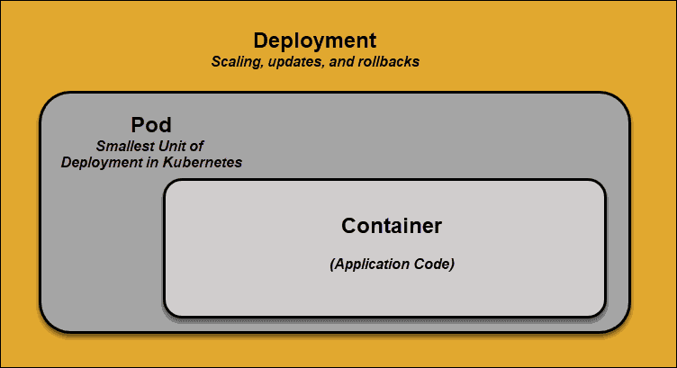

* + - The smallest element of scheduling in Kubernetes
    - A container can’t be part of cluster without a POD
    - If scaling app needed, can be only done by adding and removing pods
    - If any pod fails, Kubernetes doesn’t fix it, it creates a new pod

Kubernetes Services :-

* If a POD fails, Kubernetes creates a new POD instead of fixing this. The new pod will have a new ip address which is unreliable.
* Services are introduced to provide reliable networking by bringing stable IP addresses, DNS and ports
* By this user can add/remove any pods
* How does this service work ?-
  + Each pod associated with labels and selectors
  + A new pod automatically discovers labels that matches with selector
  + This process seamlessly adds new pods and removes terminated pods from cluster
  + The same functionalities apply for replicating/scaling pods into cluster

Container Deployments (Kubernetes Orchestrates ) :-

* Traditional Deployments

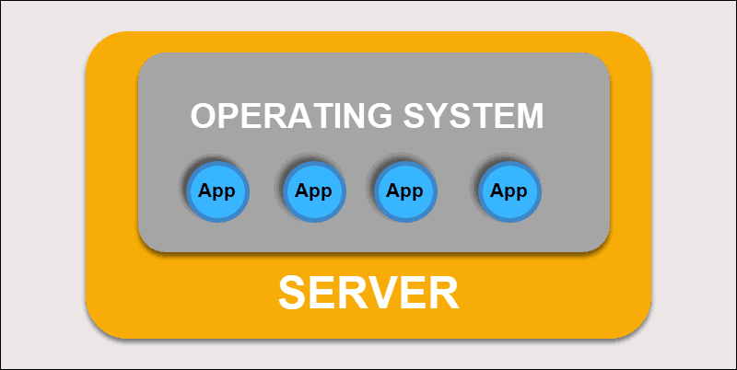

* + Deploying applications on individual physical servers
  + Problem – Applications can take up most of the processing power, limiting the performance of applications on same machine
  + Takes long time to extend hardware capacity which turns increase in cost
* Virtualized Deployments

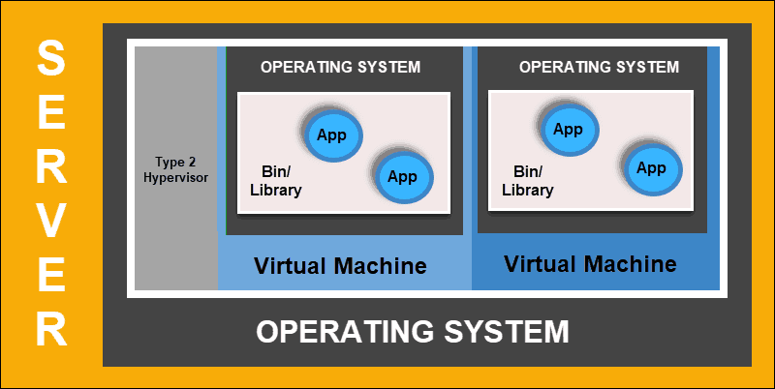

* + This deployment allows user to create isolated VM on a single physical server
  + Isolates applications within VM, limits the use of resources and increase security
  + An application can no longer freely access the information processed by another application
  + It allows to scale quickly and spread resources of a single physical server, update at will
  + It keeps hardware cost at a check
* Container Deployments

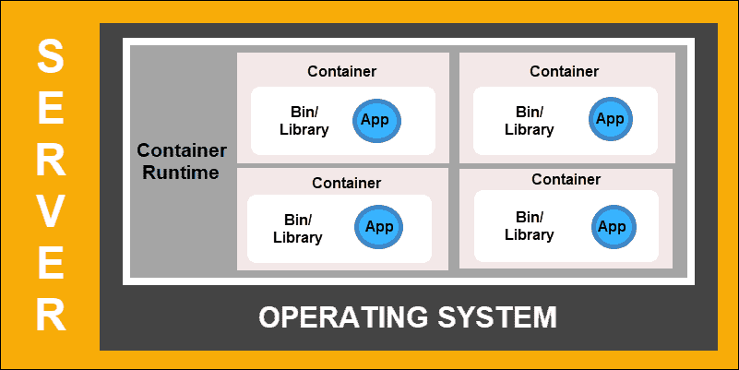

* + Most flexible and efficient model
  + Container has its own – memory, system files and processing space
  + Multiple applications can share same operating system
  + These are portable across clouds, different device and almost any OS distribution
  + It allows to run applications a smaller and independent parts which can be deployed dynamically on multiple machines

**The Building Blocks in Kubernetes :-**

* **POD :-**

* + Pod is a logical group of one or more containers that share the same host, ip address and port space
  + It supports co-located processes such as an application server and its local cache
  + Containers within a pod can find each other via localhost. Also communicates within them using standard inter-process communications like SystemV semaphores or POSIX shared memory
  + PODS are not durable
  + If node dies, pods are deleted. It can be replaced by an identical pod, with new unique Identified (UID)
  + Source :- <https://8gwifi.org/docs/kube-pods.jsp> and <https://www.stratoscale.com/blog/kubernetes/kubernetes-way-pod-controller-label/>
* Creating a POD :-
  + Through CLI :-
    - kubectl run <pod name> --image <image Name>
    - kubectl run <pod name> --image=<image name> --restart=Never
    - kubectl run <pod name> --image=<image Name> - > 1.18 + Versions
    - kubectl run nginx --image nginx
    - kubectl describe pod <pod name>
    - kubectl explain pod --recursive | less
  + Using yaml file :-
    - cat pod-defination.yaml

#Deploying a pod

apiVersion: v1

kind: Pod

metadata:

name: nginx-test

labels:

app: myapp

type: front-end

spec:

containers: #- > It creates two containers

- name: nginx-container

image: nginx

resources:

limits:

memory: “128Mi”

cpu: “500m”

- name: backend-container

image: redis

resources:

limits:

memory: “128Mi”

cpu: “500m”

* **Controller :-** 
  + Controller manages a set of pods and ensures that the cluster is in the specified state
  + There are several controller types such as :-
  + **Replication Controller**
  + **Deployment Controller**
* **Creating ReplicaSets/Replication Controllers** 
  + Responsible for running the specified number of POD copies ( replicas) across cluster
  + Helps us running multiple instances in Kubernetes cluster
  + Helps us bringing up new pod if one fails
  + A **replication controller supports** only **equality-based selectors**
  + Yaml file to create replicationController :-
    - Kind: ReplicationController

apiVersion: v1

kind: ReplicationController

metadata:

name: pod-replica

labels:

app: myapp

type: front-end

spec:

template:

metadata:

name: myapp1

labels:

app: myapp

type: front-end

spec:

containers:

- name: nginx-container

image: nginx

resources:

limits:

memory: "128Mi"

cpu: "500m"

replicas: 2

* **Deployment Controllers** 
  + Defines a desired state for logical group of pods and replica sets
  + It creates new resources or replaces the existing resources, if necessary
  + A deployment can be updated, rolled out, or rolled back
* **ReplicaSet:-**
  + It is the next-generation replication-controller
  + Monitors deployed PODs
  + **replica set** supports **set-based selectors**
  + It uses new Fields – selector and matchlabels
    - **Labels**:- A key/value pair that is attached to Kubernetes resources. Attached to resources at creation time – also can be modified later time
    - **Selectors** :- Used to organize Kubernete resources that have labels.
  + In the yaml file it need a specific version – apps/v1
  + Example of script file :-

apiVersion: apps/v1

kind: ReplicaSet

metadata:

name: rs-test

labels:

name: myapp

type: front-end

spec:

template:

metadata:

name: rs-test

labels:

name: myapp

type: front-end

spec:

containers:

- name: nginx-container

image: nginx

resources:

limits:

memory: "128Mi"

cpu: "500m"

replicas: 2

selector:

matchLabels:

type: front-end

**How do you scale the pods:-**

* Edit the yaml file and change the desired number of replicas
  + kubectl replace -f <replicaset-definition.yaml>
  + kubectl scale –replicas=6 -f <yaml file>
  + kubectl edit pod <pod name >

**Namespaces:-**

* Create namespace:
  + kubectl create namespace dev
  + pods can be created using specific namespace

#Create pod with namespace

apiVersion: v1

kind: Pod

metadata:

name: pod-test

namespace: dev

labels:

name: myapp

type: front-end

spec:

containers:

- name: nginx

image: nginx

resources:

limits:

memory: "128Mi"

cpu: "100m"

* + **To view pods** in a namespace - kubectl get pods --namespace=dev
  + **To change the namespace from default to choice of yours :-**
  + **kubectl config set-context $(kubectl config current-context) –namespace=dev**
  + **kubectl get pods --all-namespaces** – To see pods running in all namespaces
* **Resource Quota:-**
  + Restricting the number of pods, mem, cpu etc in a namespace
  + Using yaml file

#Create namespace using resource QUOTA

apiVersion: v1

kind: ResourceQuota

metadata:

name: quota

namespace: dev

spec:

hard:

pods: "10"

requests.cpu: "4"

requests.memory: "5Gi"

limits.cpu: "1"

limits.memory: "1Gi"

* **Service (s)**
  + A service uses selector to define logical groups of pod and defines a policy to access such logical group
  + There are several types of services in Kubernetes such as :-
    - ClusterIp ( Exposes pods to connections from inside the cluster )
    - NodePort ( Exposes pods to external traffic by forwarding traffic from a port on each node of cluster to the container port
    - LoadBalancer ( Exposes pods to external traffic, as NodePort Service does. Also does load balancing)
  + Helps us connect application together with other applications
  + Makes connection between front-end and back-end pods
  + It has extra field and selectors are used for connecting to pods
  + A sample yaml file

apiVersion: v1

kind: Service

metadata:

name: svc-test

labels:

name: myapp

type: front-end

spec:

type: NodePort

ports:

- targetPort: 80

port: 80

nodePort: 30008

# Used for creating pod

selector:

app: myapp

type: front-end

* **Service Cluster IP:-**
  + This is used to create a single interface talking to backend and front-end
  + This can be defined in the yaml file as bellow:-

#Defining Service ClusterIP

apiVersion: v1

kind: Service

metadata:

name: back-end

spec:

type: ClusterIP

ports:

- targetPort: 80

port: 80

selector:

name: myapp

type: back-end

* **Service LoadBalancer**
  + This is supported by few cloud vendors such as AWS, Azure and GCP
  + This is similar to service definition file such as

apiVersion: v1

kind: Servie

metadata:

name: front-end

spec:

type: LoadBalancer

ports:

* targetPort: 80

port: 80

NodePort: 30008

* Imperative VS Declarative –
  + <https://viasat.udemy.com/course/certified-kubernetes-administrator-with-practice-tests/learn/lecture/15018998#notes>
  + <https://kubernetes.io/docs/reference/kubectl/conventions/>
  + Imperative – Commands
    - kubectl run --image=nginx nginx
    - kubectl create deployment --image=nginx nginx
    - kubectl expose deployment nginx --port 80
    - kubectl edit deployment nginx
    - kubectl scale deployment nginx --replicas=5
    - kubectl set image deployment nginx nginx:1.18
    - kubectl create -f nginx.yaml
    - kubectl replace -f nginx.yaml
    - kubectl delete -f nginx.yaml
    - kubectl replace --force -f nginx.yaml
    - kubectl create service clusterip redis-service --tcp=6379:6379 – Creating a service
    - kubectl create deployment webapp --image=kodekloud/webapp-color --replicas=3 – Creating a deployment
    - kubectl run httpd --image=httpd:alpine --port=80 –expose – Exposing a pod with services
    - kubectl run custom-nginx --image=nginx --port=8080 --expose – Expose a pod
    - kubectl create deployment redis-deploy --image=redis --namespace=dev-ns --dry-run=client -0 -yaml > test.yaml
  + Declarative – Commands
    - kubectl apply -f nginx.yaml – Making a change in the setup/file
* **Scheduling** 
  + A nodeName must be defined while creating pod. It cant be updted in run-time. You have to delete and recreate the pod
  + The file can be seen as :-

#Scheduling defination for POD

apiVersion: v1

kind: Pod

metadata:

name: pod-test

labels:

name: myapp

type: front-end

spec:

nodeName: master

containers:

- name: nginx

image: nginx

resources:

limits:

cpu: "500m"

memory: "128Mi"

* + kubectl -n kube-system get pods - to show the control plane components
* **Labels and Selectors:-**
  + kubectl get pods --selector env=dev – To get the number of pods running with that lebels
  + kubectl get pods --show-labels - > To show the labels in pods
  + kubectl get pods -l --env=prod,tier=frontend,bu=finance - > Use command separated
  + kubectl get nodes node01 --show-labels - > To show node labels
  + kubectl label node node01 color=blue - > Label a node
* Taints and Tolerations
  + Kubectl taint nodes node1 app=blue:NoSchedule
  + All the values will be in quotes
  + To see the nodes tainted or not :- kubectl describe node node01 | grep -i taint
  + kubectl explain pod --recursive | grep -A5 tolerations < - Help on tolerations
  + This can be seen as :-

# Pod definations with taints

apiVersion: v1

kind: Pod

metadata:

name: test-pod

labels:

name: myapp

type: front-end

spec:

containers:

- name: nginx-containers

image: nginx

resources:

limits:

memory: "128Mi"

cpu: "500m"

tolerations:

- key: "app"

operator: "Equal"

value: "blue"

effect: "NoSchedule"

* **Node Selector :-**
  + Used to select which pods to go which node
  + Useful for putting high and low performance pods into different nodes
  + This can be done by selecting the NodeSelector values in pod creation
    - First label the nodes and that can be done by using
    - kubectl label nodes <Node Name> <label-key>=<label value>
    - e.g – kubectl label nodes node1 size=Large
  + We can’t use the above steps if users have multiple nodes and having multiple sizes. So to overcome this we have to use node-affinity services
* **Node Affinity:-**
  + These has different terms and key values
    - requiredDuringSchedulingIgnoredDuringExecution
    - preferredDuringSchedulingIgnoredDuringExecution
  + This can be defined as :-

apiVersion: apps/v1

kind: Deployment

metadata:

name: blue

spec:

replicas: 6

selector:

matchLabels:

run: nginx

template:

metadata:

labels:

run: nginx

spec:

containers:

- image: nginx

imagePullPolicy: Always

name: nginx

affinity:

nodeAffinity:

requiredDuringSchedulingIgnoredDuringExecution:

nodeSelectorTerms:

- matchExpressions:

- key: color

operator: In

values:

- blue

* **Resources Requirements and Limits:-**
  + Minimum resources needed by containers – 0.5M CPU and 256Mi Memory
  + 1M - > 1 mili
* **DaemonSets**:-
  + Are like replicasets
  + Created by Kube-API server ( DaemonSet Controller)
  + Deploy Monitoring Agents, Logging Agents on Node
  + It make sure every node has a pod
  + It is deprecated from v1.12 and replaced by nodeaffinity
  + The definition or it can be same as replicaSet except the kind: DaemonSet
  + kubectl get daemonsets - > To get the daemonsets
  + kubectl describe daemonsets kube-flannel-ds-amd64 --namespace=kube-system - > To view the namespaces daemonsets deployed
* **Static Pods** :-
  + Used to deploy control plane components nodes on a pod ( Static Pod)
  + Created by Kubelets
  + The config files stays in - /etc/kubernetes/manifests
  + kubectl run static-busybox --image=busybox --dry-run=client -o yaml --command -- sleep=1000 > /etc/kubernetes/manifests/busybox.yaml – >> Create a static POD
  + The files can be stored in /etc/kubernetes/manifests
  + “ps -ef | grep kubelet - > Serach for config” - > This should show the staci pod path
* **Multiple Scheduler:-**
  + kubectl get events
  + kubectl logs
* **Logging and Monitoring Clusters:-**
  + Metrics Servers – Each cluster will have this.
  + minikube addons enable metrics-server – To add in Monitoring services
  + For other environment – git clone the metrics server and run the yamls ( kubectl create -f .)
  + kubectl top node
  + kubectl top pod
  + the metrics server can defined as :-

---

apiVersion: v1

kind: Service

metadata:

name: metrics-server

namespace: kube-system

labels:

kubernetes.io/name: "Metrics-server"

spec:

selector:

k8s-app: metrics-server

ports:

- port: 443

protocol: TCP

targetPort: 443

* **Managing Application Logs** 
  + kubectl logs -f <Name> - > To check the logs
  + If multiple containers are running try this - kubectl logs webapp-2 -c simple-webapp
* **Application LifeCycle Managements**
* **Rolling Updates and Rollbacks** 
  + kubectl rollout status deployment/<Name>
  + kubectl rollout history deployment/<Name>
  + Recreate strategy
  + Rolling Upgrade Strategy
  + 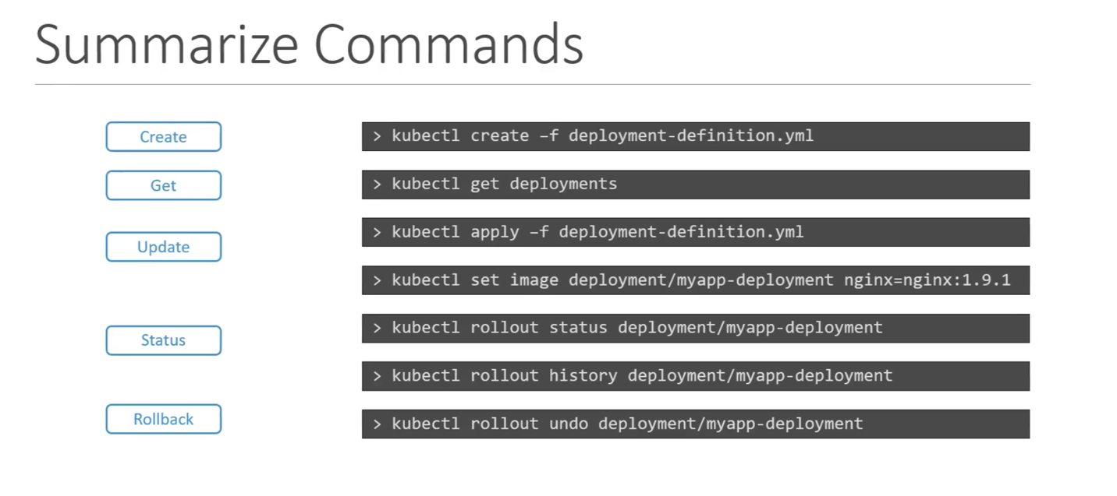
* Configure Applications :-
  + Configuring Command and Argument on Applications
  + Commands and Arguments

apiVersion: v1

kind: Pod

metadata:

name: ubuntu-sleeper-2

spec:

containers:

- name: ubuntu

image: ubuntu

command:

- "sleep"

- "5000"

* + Configuring Environment Variables [ The variable are arrays ]

apiVersion: v1

kind: Pod

metadata:

name: ubuntu-sleeper-2

spec:

containers:

- name: ubuntu

image: ubuntu

env:

- "sleep"

- "5000"

* + ConfigMap
    - [ kubectl create configmap <name> --from-literal=<cariables>
    - e.g – kubectl create configmap test1 -from-literal=APP_COLOR=darkblue
    - kubectl explain pods --recursive | grep envFrom -A3 – To search something with commands

apiVersion: v1

kind: ConfigMap

metadata:

name: ubuntu-sleeper-2

data:

APP_COLOR: blue

APP_MODE: prod

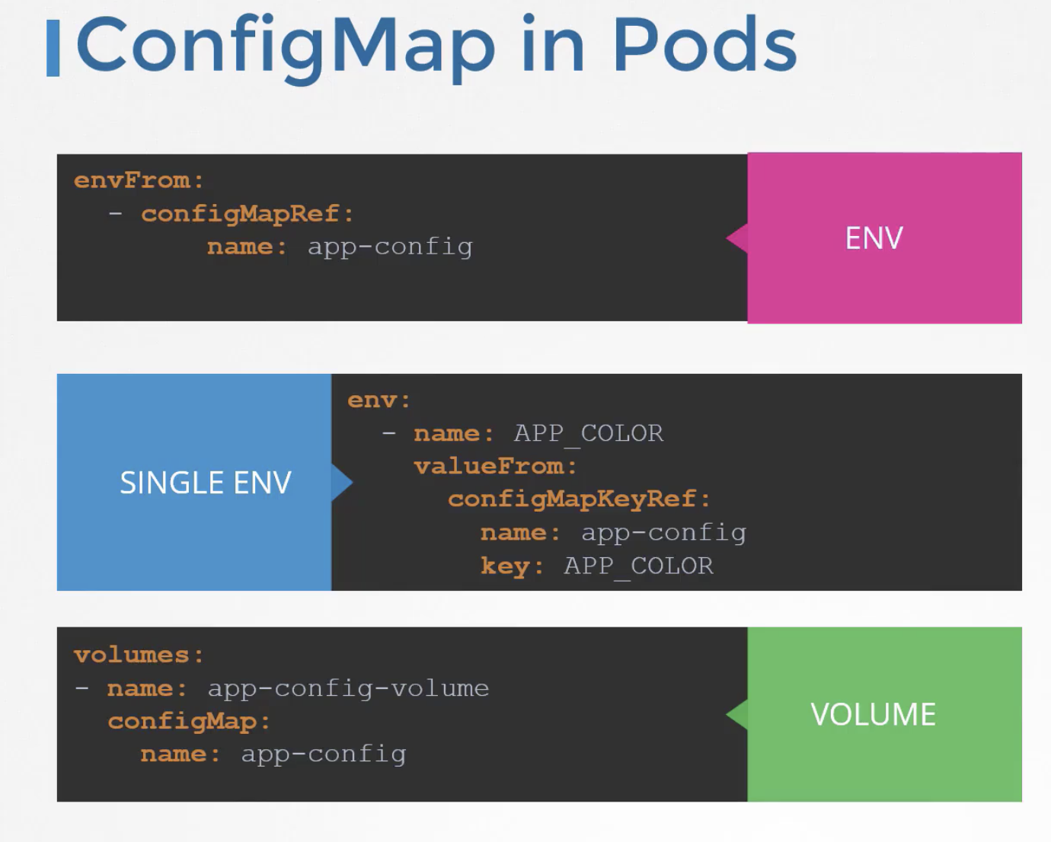

* + Configuring Secrets

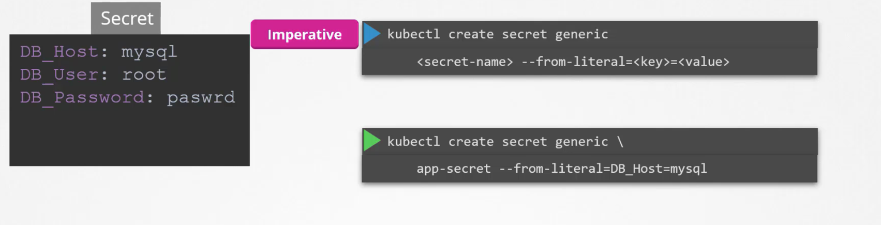

* + - Create a secret
      * This can be created using bellow command:-
      * kubectl create secret generic <secret name> --from-literal=<key>=<value>

e.g - kubectl create secret generic db-secret --from-literal=DB_Host=sql01 --from-literal=DB_User=root --from-literal=DB_Password=password123

* + - * Converting cleartest username and password into secret values
        + echo -n ‘mysql’ | base64
        + echo -n ‘password’ | base64
        + echo -n ‘root’ | base64
        + echo -n ‘root’ | base64 --decode [ Decode ]
      * kubectl get secrets - > To get the secret configured
      * kubectl describe secrets
      * The definition file can be wrriten as :-

apiVersion: v1

kind: Secret

metadata:

name: app-secret

data:

DB_Host: <secret host >

DB_User: <secret user>

DB_Password: <secret password >

OR

apiVersion: v1

kind: Pod

metadata:

name: app-secret

spec:

containers:

- image: kodekloud/simple-webapp-mysql

name: webapp

envFrom:

- secretRef:

name: db-secret

* + - Inject the secret

* Multiple pods :-
  + The multiple pods can be created as :-

apiVersion: v1

kind: Pod

metadata:

labels:

run: yellow

name: yellow

spec:

containers:

- image: busybox

name: lemon

- image: redis

name: gold

* + To check logs on a pod
  + kubectl -n elastic-stack exec -it app cat /log/app.log
* Multi-Container Design patterns:- ( Needed in CKAD exam )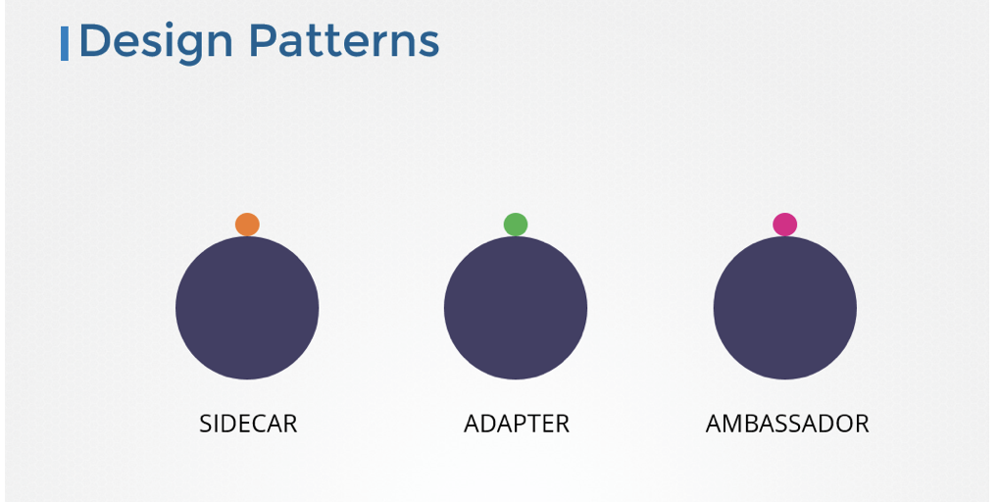
  + Sidecar pattern
  + Adapter Pattern
  + Ambassador pattern
* InitContainers:-

1. apiVersion: v1
2. kind: Pod
3. metadata:
4. name: myapp-pod
5. labels:
6. app: myapp
7. spec:
8. containers:
9. - name: myapp-container
10. image: busybox:1.28
11. command: ['sh', '-c', 'echo The app is running! && sleep 3600']
12. initContainers:
13. - name: init-myservice
14. image: busybox
15. command: ['sh', '-c', 'git clone <some-repository-that-will-be-used-by-application> ; done;']

* Cluster Maintenance :-
  + OS upgrade
  + Un-schedule a node
    - kubectl drain node01 --ignore-daemonsets –
    - kubectl drian <Node Name >
  + kubectl cordon - > Mark node as unschedulable
  + kubectl uncordon -> Mark node as schedulable
  + kubectl cordon node03
  + kubectl uncordon node01 - Configure the node to be schedulable again.
* Cluster Upgrade
  + kubeadm upgrade plan
  + kubeadm upgrade apply <>
  + We should upgrade 1 minor version at a time 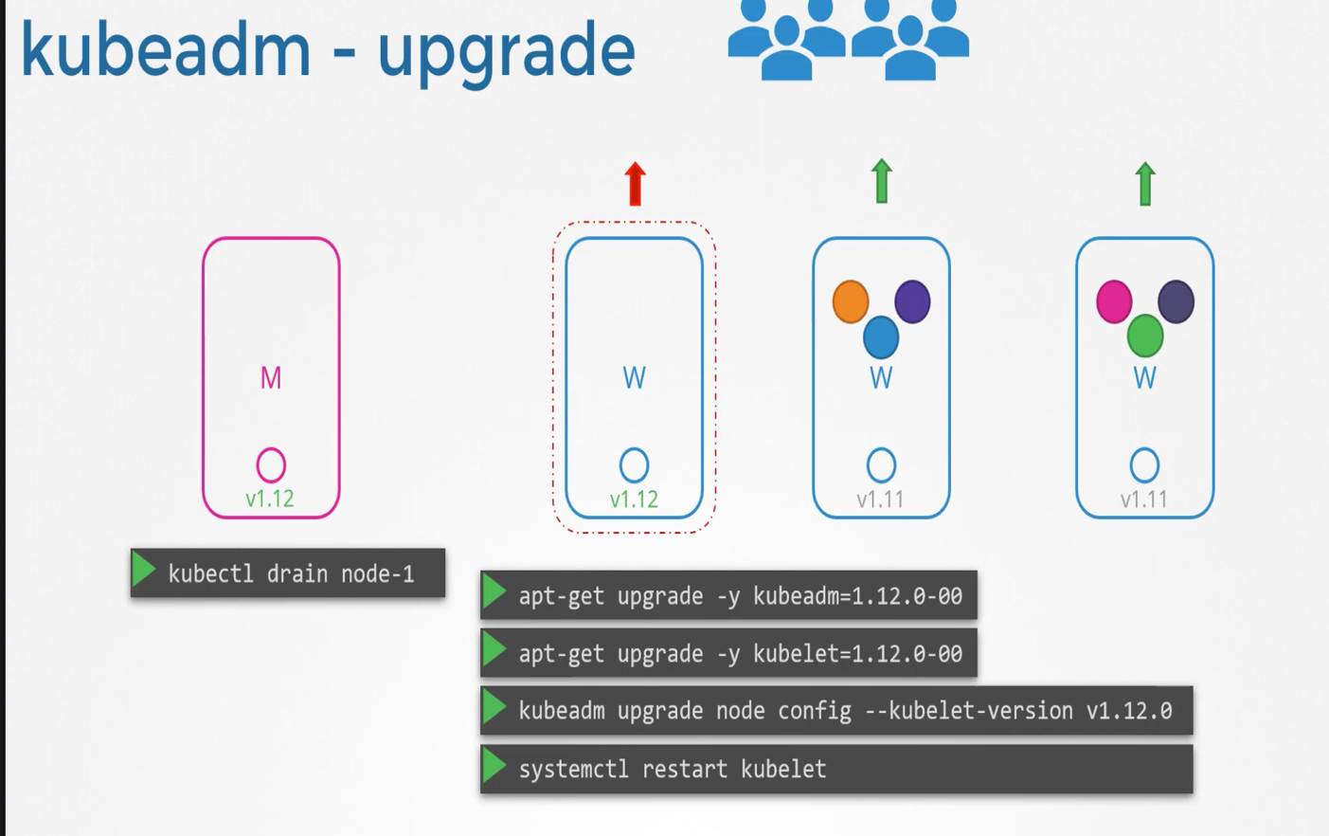
  + Kubeadm doesn’t upgrade kubelet
  + To unscheduled a node you can run –
  + kubectl drian master/controlplane --ignore-daemonsets
  + How to upgrade a cluster or kubelet
    - Run the command apt update, apt install kubeadm=1.19.0-00 and then kubeadm upgrade apply v1.19.0 and then  apt install kubelet=1.19.0-00 to upgrade the kubelet on the master node
  + How to upgrade a Node ( Not master )
    - Run the commands: apt update, apt install kubeadm=1.19.0-00 and then kubeadm upgrade node. Finally, run apt install kubelet=1.19.0-00.
* Backup and Restore Methods:-
  + To get all pods in namespace – kubectl get all --all-namespaces
  + To check which node to check where is etcd running - Use the command kubectl describe pod etcd-controlplane -n kube-system and look for --listen-client-urls
* Security
  + Controlling the kube-apiserver is the main source for security
  + Who can access ? (Access)
  + What can they do ? ( Authorization )
  + Restrict access – Using Network Policy
  + We cant create normal user with kubectl command
  + A service account can be created using ( kubectl create sericeaccount sa1)
  + kubectl get serviceaccount - > to get the service accounts
  + kube-apiserver – can be accessed using – Password file and Token files
  + The password file has 3 sections – password, user, type, groups e.g – password, test, u001,group01
  + The above file needs to be updated in – kube-apiserver.service (--basic-auth-file=user-details.csv)
  + For token it would be (--token-auth-file=token.csv )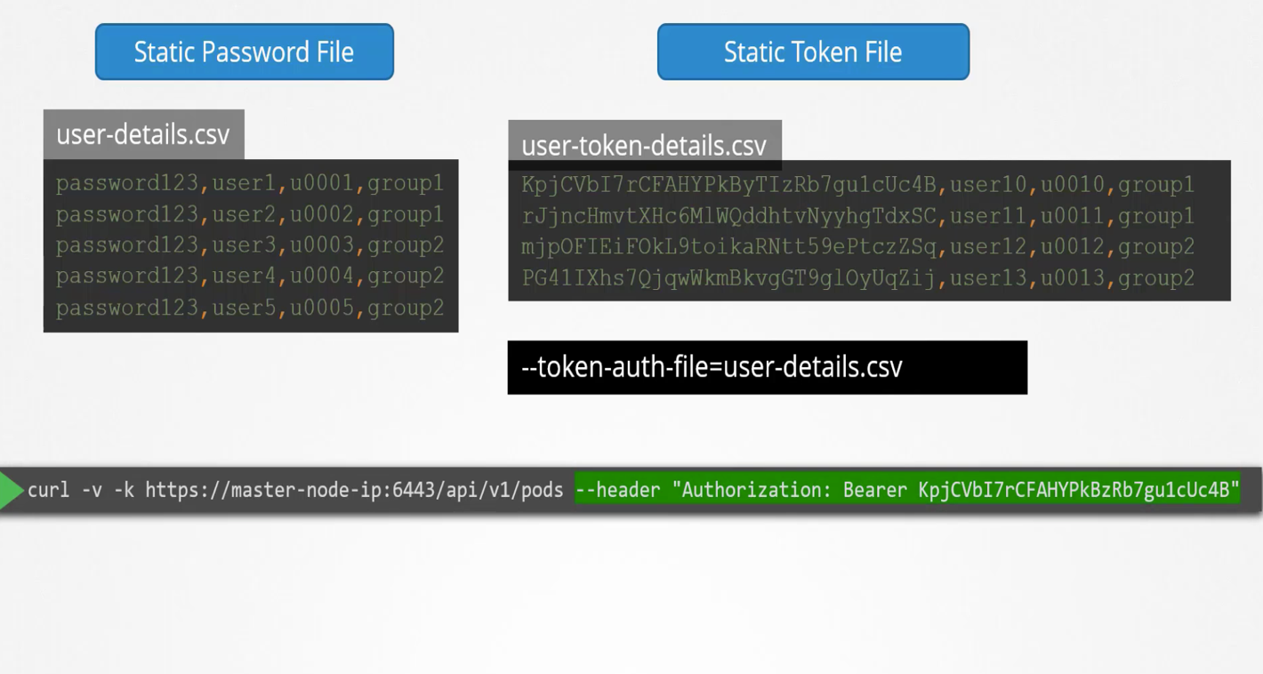
  + Key Certificates and types :-

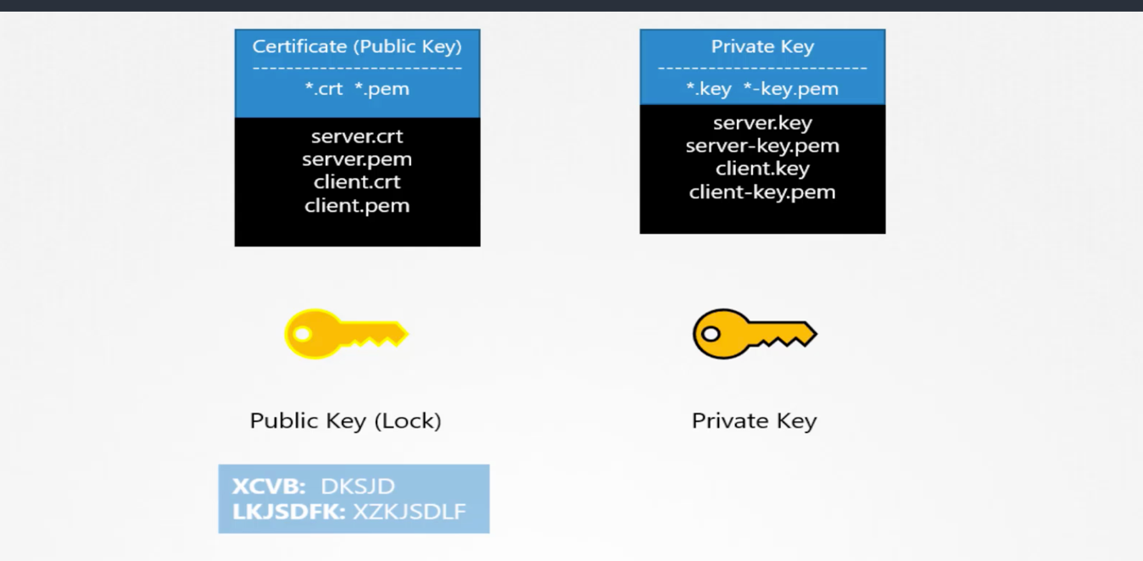

* + Public keys are named with .crt or .pem
  + Private keys are names with .key or -key.pem
  + Types of Certificates
    - Server certificate
    - Client certificate
    - Root Certificate 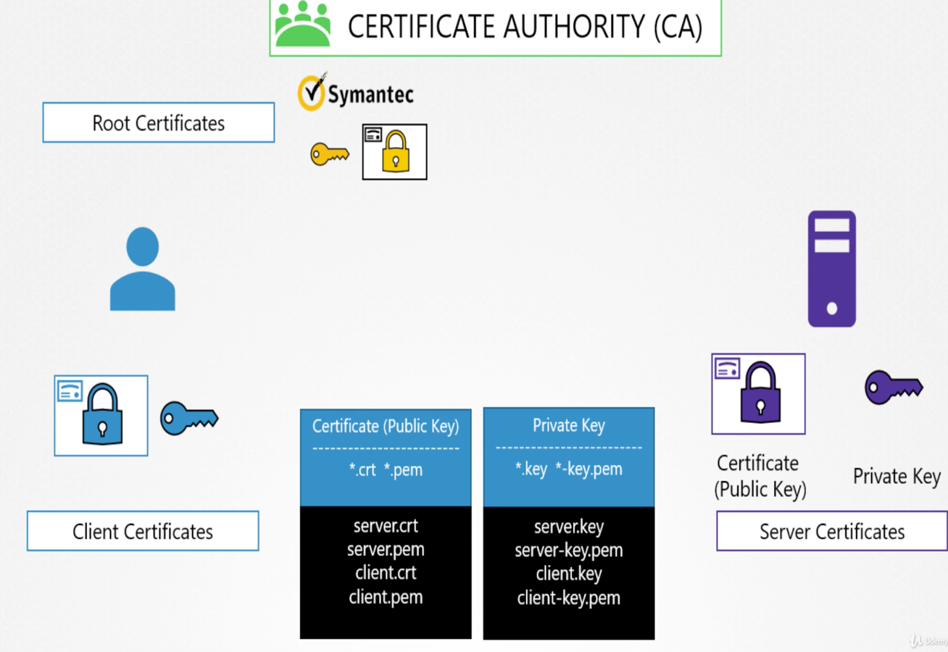
  + Server certificates

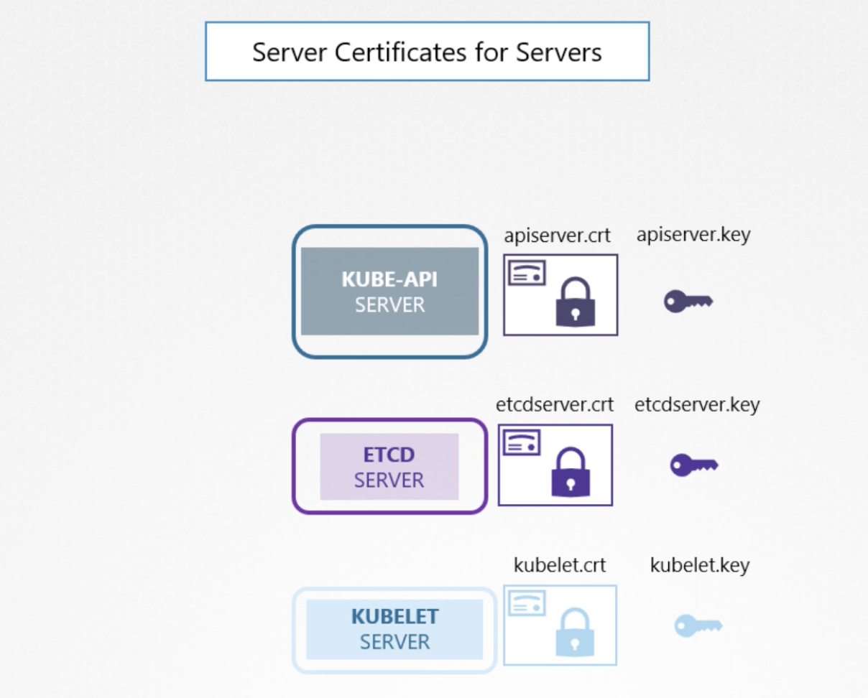

* + Client Certificates
  + 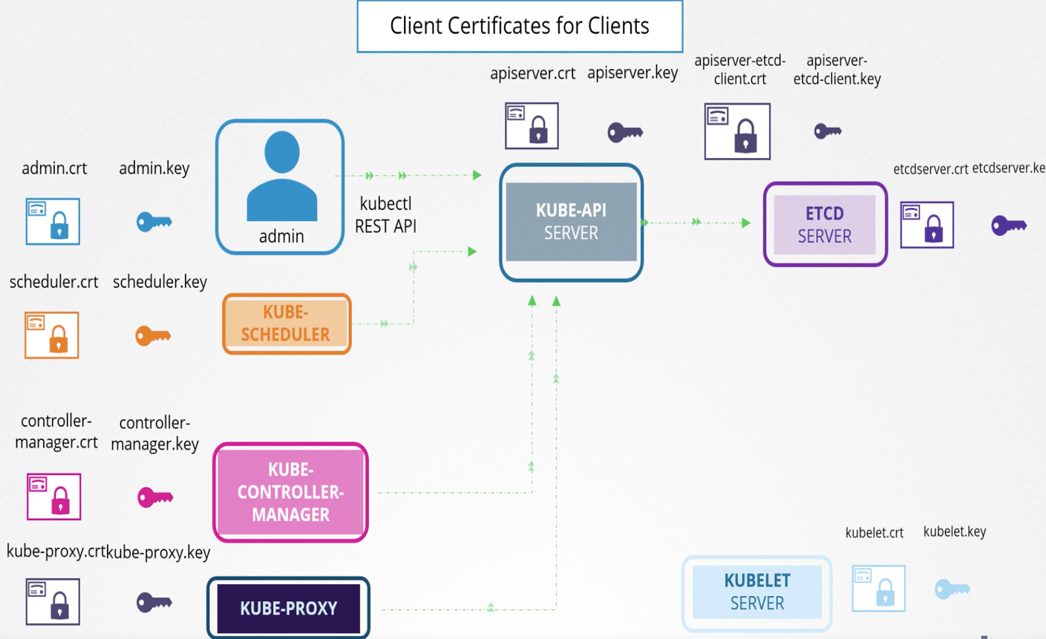
  + Client and Server Certificate

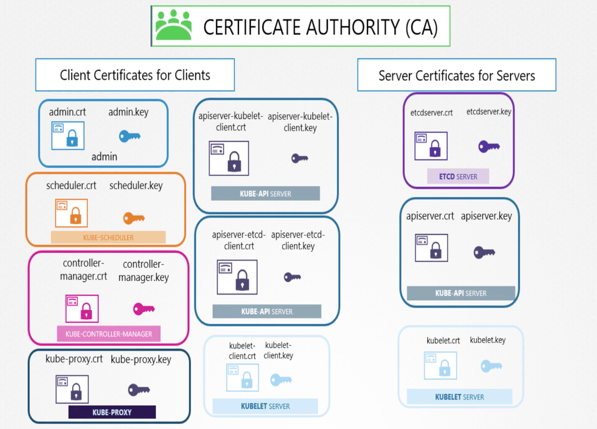

* + Root Certificate
  + How to generate a certificate ( OPENSSL ) – Server Certificate
    - (openssl genrsa -out ca.key 2048 )
    - Create a Sign-in certificate (openssl req -new -key ca.key -subj “/CN=KUBERNETES-CA” -out ca.csr )
    - CN = Common Name
    - Signin the key (openssl x509 -req -in ca.csr -signkey ca.key -out ca.crt )
  + Generate the Client Certificate
    - Generate admin key ( openssl genrsa -out admin.key 2048 )
    - Create sign-in certificate ( openssl req -new -key admin.key -subj “/CN=kube-admin” -out admin.csr )
    - Sign in the key using CA Certificate ( openssl x509 -req -in admin.csr -CA ca.crt -CAkey ca.key -out admin.crt )
    - 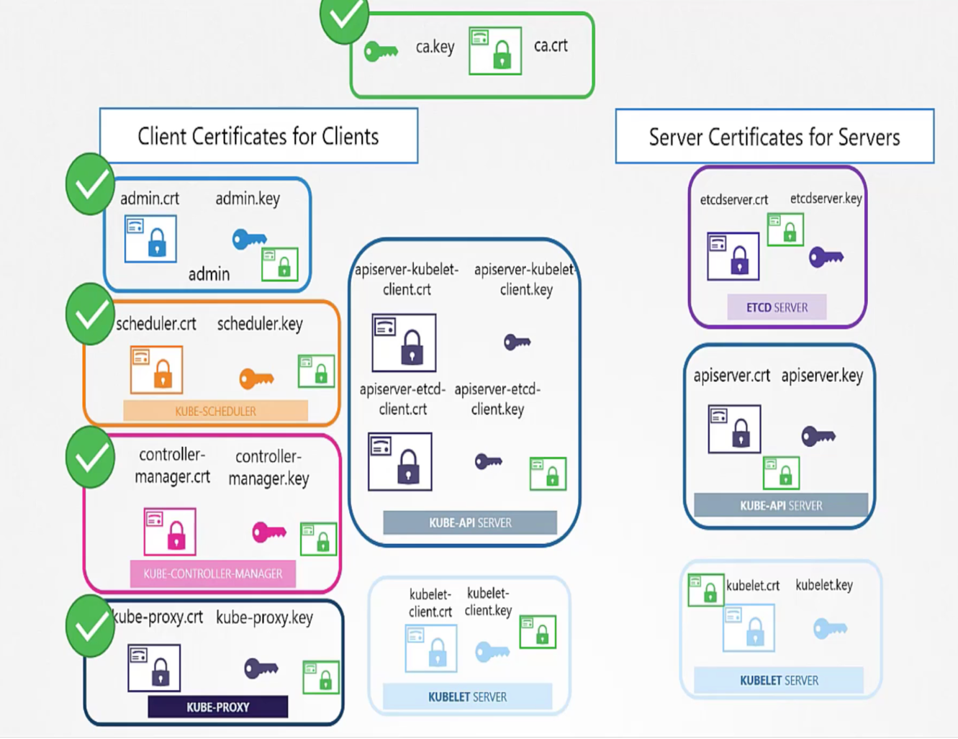
  + Viewing Certificates

* + Extracting a CN from a certificate – ( openssl x509 -in /etc/kubernetes/pki/apiserver.crt -text )
  + For etcd server ( openssl x509 -in /etc/kubernetes/pki/etcd/server.crt -text | grep CN )
  + Verifying certificates for different servers

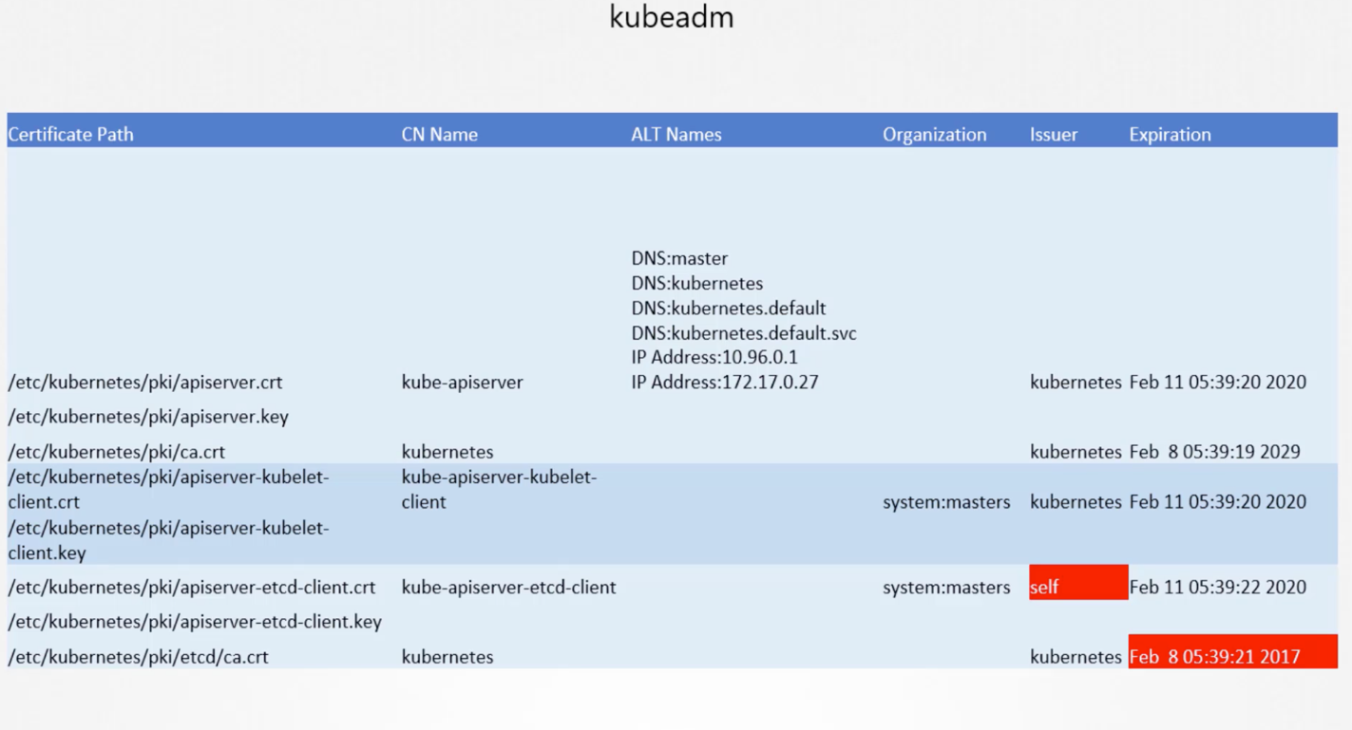

* + View Logs:-
    - Check the pods – docker ps -a
    - Docker logs ( docker logs < Docker ID > )
* How to create a Signing Request
  + Generate keys
* openssl genrsa -out john.key 2048
* openssl req -new -key john.key -out john.csr
  + Create yaml file

apiVersion: certificates.k8s.io/v1beta1

kind: CertificateSigningRequest

metadata:

name: akshay

spec:

signerName: kubernetes.io/kube-apiserver-client

groups:

- system:authenticated

request: <Put the key >

usages:

- digital signature

- key encipherment

- server auth

* + Apply the file
  + Getting the certificate state - kubectl get csr
  + Approve the certificate - kubectl certificate approve akshay
  + To check more details - kubectl get csr <Name> -o yaml
  + Deny a user :- kubectl certificate deny agent-smith
* Kubeconfig
  + A config can be found in $HOME/.kube/config
  + It has 3 sections – Clusters, Users and Contexts

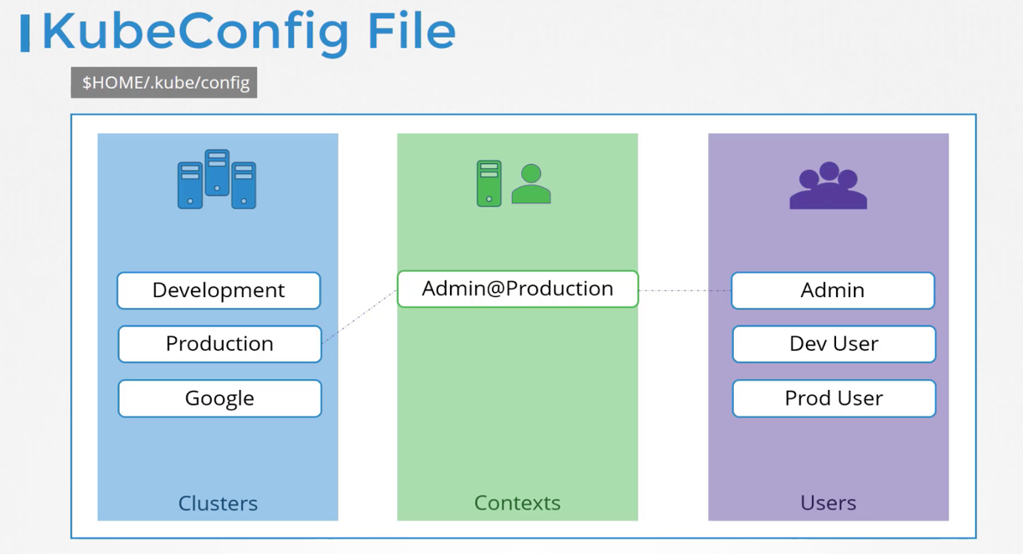

* + A detailed config file

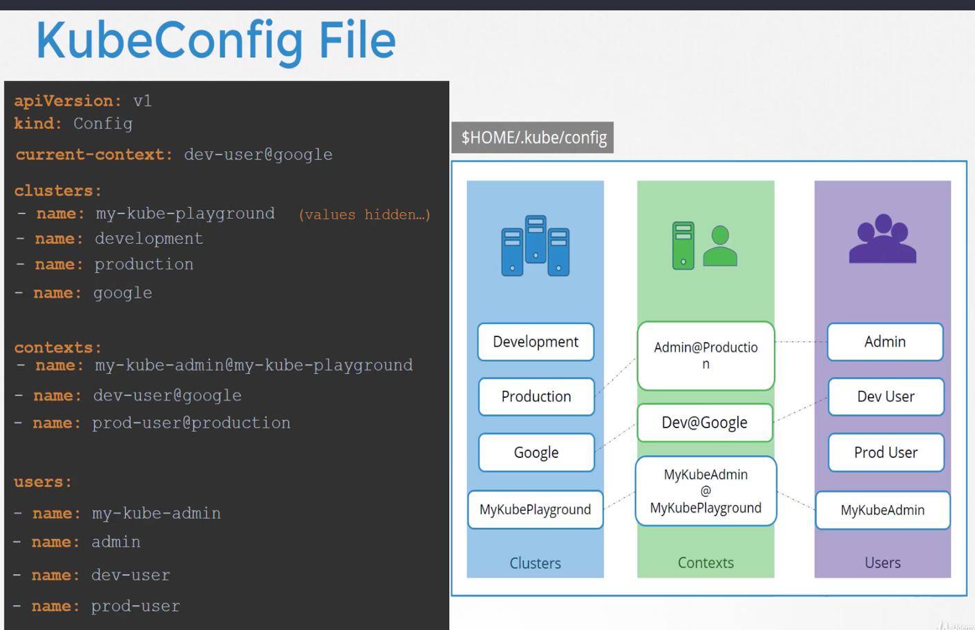

* + To view the config file run – “ kubectl config view “
  + To change the contexts run – “kubectl config use-context <New contexts name – e.g prod@prod-cluster>”
  + To see the help commands :- kubectl config -h
* RBAC:-
  + Verify the Authorization “kubectl describe pod kube-apiserver-controlplane -n kube-system | grep -i auth”
  + 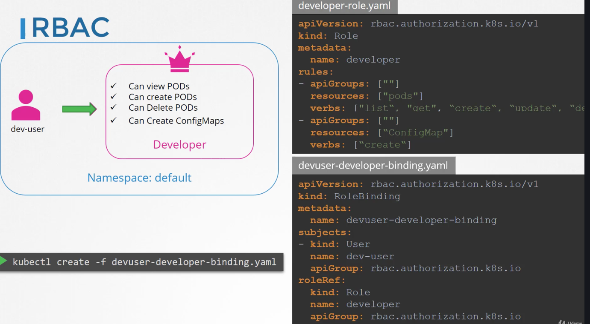
  + Kubectl get roles
  + Kubectl get rolebindings
  + Kubectl describe role developers
  + kubectl get roles --all-namespaces – To check roles defined in all name spaces
  + Get details of a user in a name-space ( kubectl describe role kube-proxy -n kube-system )
  + Role-bindings :-

*kubectl describe rolebindings kube-proxy -n kube-system*

*Name: kube-proxy*

*Labels: <none>*

*Annotations: <none>*

*Role:*

*Kind: Role*

*Name: kube-proxy*

*Subjects:*

*Kind Name Namespace*

*---- ---- ---------*

*Group system:bootstrappers:kubeadm:default-node-token*

* + To check pods with specific user ( kubectl get pods --as dev-user )

controlplane $ cat dev_user.yaml

*apiVersion: rbac.authorization.k8s.io/v1*

*kind: Role*

*metadata:*

*name: developer*

*rules:*

*- apiGroups: [""]*

*resources: ["pods"]*

*verbs: ["list" , "get"]*

*- apiGroups: [""]*

*resources: ["ConfigMap"]*

*verbs: ["create"]*

controlplane $ cat dev_user-bindings.yaml

*apiVersion: rbac.authorization.k8s.io/v1*

*kind: RoleBinding*

*metadata:*

*name: dev-user-binding*

*subjects:*

*- kind: User*

*name: dev-user*

*apiGroup: rbac.authorization.k8s.io*

*roleRef:*

*kind: Role*

*name: developer*

*apiGroup: rbac.authorization.k8s.io*

* + Combing them into a single file:-

*controlplane $ cat /var/answers/dev-user-deploy.yaml*

*---*

*kind: Role*

*apiVersion: rbac.authorization.k8s.io/v1*

*metadata:*

*namespace: blue*

*name: deploy-role*

*rules:*

*- apiGroups: ["apps", "extensions"]*

*resources: ["deployments"]*

*verbs: ["create"]*

*---*

*kind: RoleBinding*

*apiVersion: rbac.authorization.k8s.io/v1*

*metadata:*

*name: dev-user-deploy-binding*

*namespace: blue*

*subjects:*

*- kind: User*

*name: dev-user*

*apiGroup: rbac.authorization.k8s.io*

*roleRef:*

*kind: Role*

*name: deploy-role*

*apiGroup: rbac.authorization.k8s.io*

* + Cluster Roles and Role bindings
  + A cluster roles can be defined as :-

*apiVersion: rbac.authorization.k8s.io/v1*

*kind: ClusterRole*

*metadata:*

*name: Cluster-Administrator*

*rules:*

* *apiGroups: []*

*resources: [“nodes”]*

*verbs: [“get”, “list”, “create”, “delete”]*

kubectl create -f <File name > - > To create cluster roles

* + A clusterrole bindings can be defined as bellow which is used to link users to cluster roles:-

*apiVersion: rbac.authorization.k8s.io/v1*

*kind: ClusterRoleBinding*

*metadata:*

*name: cluster-admin-rolebinding*

*subjects:*

* *kind: User*

*name: cluster-admin*

*apiGroup: rbac.authorization.k8s.io*

*roleref:*

*kind: ClusterRole*

*name: Cluster-Adminstrator*

*apiGroup: rbac.authorization.k8s.io*

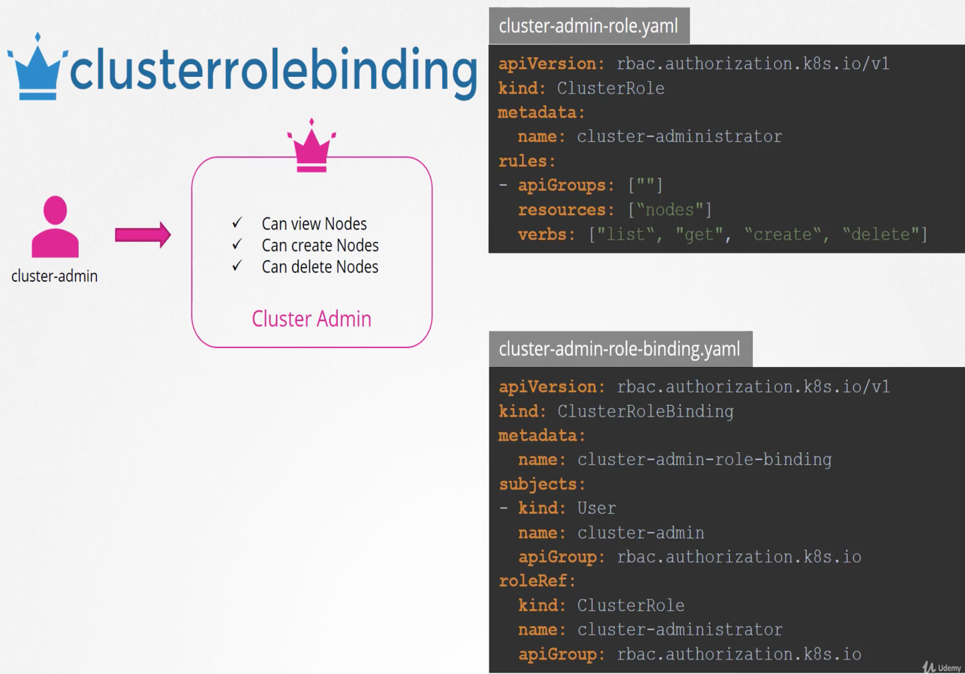

* + Getting Number of clusterroles
    - kubectl get clusterroles --no-headers | wc -l
    - kubectl get clusterroles --all-namespaces --no-headers | wc -l
  + Get Number of clusterrolebindings
    - kubectl get clusterrolebinding --all-namespaces --no-headers | wc -l
    - kubectl get clusterrolebindings --no-headers | wc -l
  + To view the groups and users
    - kubectl describe clusterrolebindings <User>
  + Create a storage groups :-

*---*

*kind: ClusterRole*

*apiVersion: rbac.authorization.k8s.io/v1*

*metadata:*

*name: storage-admin*

*rules:*

*- apiGroups: [""]*

*resources: ["persistentvolumes"]*

*verbs: ["get", "watch", "list", "create", "delete"]*

*- apiGroups: ["storage.k8s.io"]*

*resources: ["storageclasses"]*

*verbs: ["get", "watch", "list", "create", "delete"]*

*---*

*kind: ClusterRoleBinding*

*apiVersion: rbac.authorization.k8s.io/v1*

*metadata:*

*name: michelle-storage-admin*

*subjects:*

*- kind: User*

*name: michelle*

*apiGroup: rbac.authorization.k8s.io*

*roleRef:*

*kind: ClusterRole*

*name: storage-admin*

*apiGroup: rbac.authorization.k8s.io*

* Image :-
  + Image: nginx/nginx

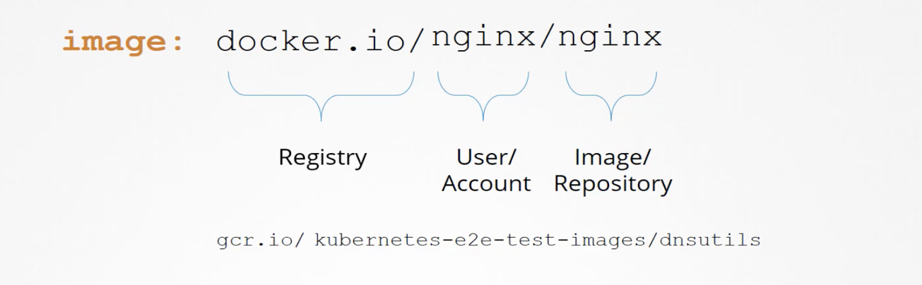

* + A pod definition can be written as : -

*apiVersion: v1*

*kind: Pod*

*metadata:*

*name: nginx-pod*

*spec:*

*containers:*

* *name: nginx*

*image: private-registry.io/apps/internal-app*

*imagePullSecrets:*

* *name: regcred*

* + To change the image registry by editing deployments
  + Create a secret :- *kubectl create secret docker-registry private-reg-cred --docker-username=dock_user --docker-password=dock_password --docker-server=myprivateregistry.com:5000 --docker-email=dock_user@myprivateregistry.com*
* Secret Contents :
  + It can be defined as :-

*apiVersion: v1*

*kind: Pod*

*metadata:*

*name: ubuntu-sleeper*

*namespace: default*

*spec:*

*securityContext:*

*runAsUser: 1010*

*containers:*

*- command:*

*- sleep*

*- "4800"*

*image: ubuntu*

*name: ubuntu-sleeper*

* + To get the User Details :- kubectl exec ubuntu-sleeper – whoami
  + Set a date in docker :- *kubectl exec -it ubuntu-sleeper -- date -s '19 APR 2012 11:14:00'*
  + To check the logs :- kubectl exec webapp –cat /log/app.log
* Network Policies
  + 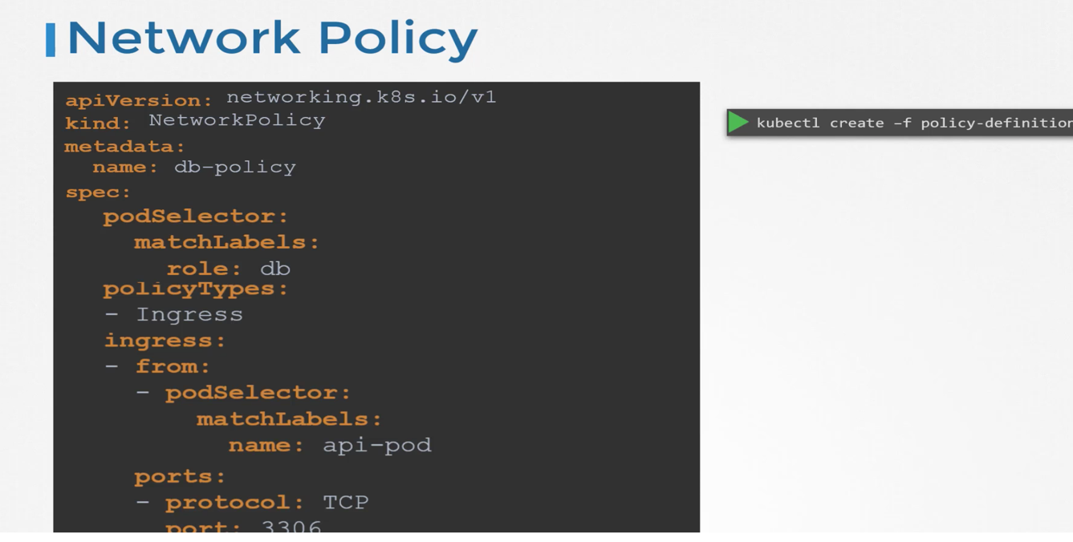
  + OR
* **apiVersion**: networking.k8s.io/v1
* **kind**: NetworkPolicy
* **metadata**:
* **name**: test-network-policy
* **namespace**: default
* **spec**:
* **podSelector**:
* **matchLabels**:
* **role**: db
* **policyTypes**:
* - Ingress
* - Egress
* **ingress**:
* - **from**:
* - **ipBlock**:
* **cidr**: 172.17.0.0/16
* **except**:
* - 172.17.1.0/24
* - **namespaceSelector**:
* **matchLabels**:
* **project**: myproject
* - **podSelector**:
* **matchLabels**:
* **role**: frontend
* **ports**:
* - **protocol**: TCP
* **port**: 6379
* **egress**:
* - **to**:
* - **ipBlock**:
* **cidr**: 10.0.0.0/24
* **ports**:
* - **protocol**: TCP
* **port**: 5978
* Storage :-

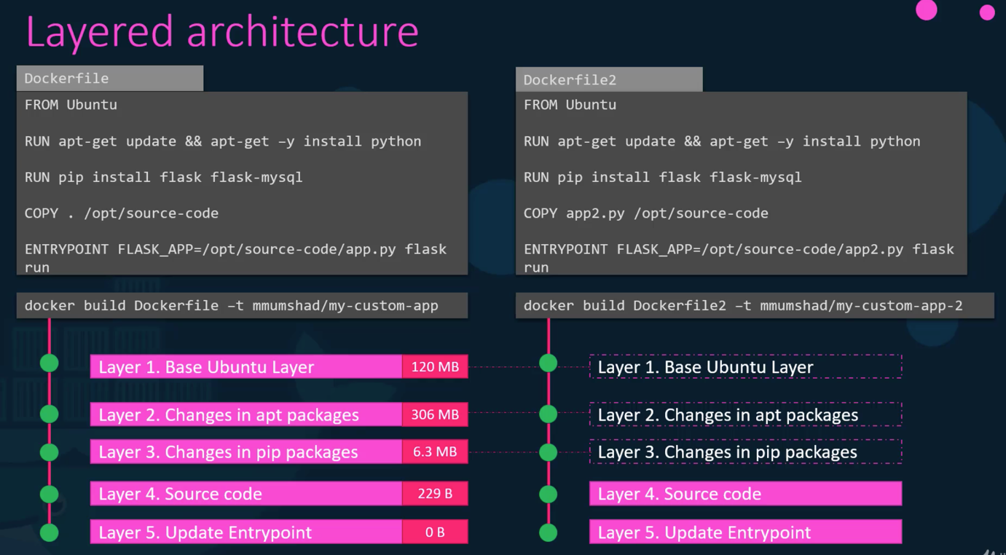

* + Persistent volumes can be defined as:-
* apiVersion: v1
* kind: Pod
* metadata:
* name: mypod
* spec:
* containers:
* - name: myfrontend
* image: nginx
* volumeMounts:
* - mountPath: "/var/www/html"
* name: mypd
* volumes:
* - name: mypd
* persistentVolumeClaim:
* claimName: myclaim
* Storage Class:-
  + Get storage class – kubectl get sc
  + Get PersistentVolume Claim - kubectl get pvc
  + Get Persistent Volume - kubectl get pv
  + A storage class can be written as:-

*apiVersion: storage.k8s.io/v1*

*kind: StorageClass*

*metadata:*

*name: delayed-volume-sc*

*provisioner: kubernetes.io/no-provisioner*

*volumeBindingMode: WaitForFirstConsumer*

* Networking
  + Docker Networking
  + Docker CNI ( Container Networking Interfaces )

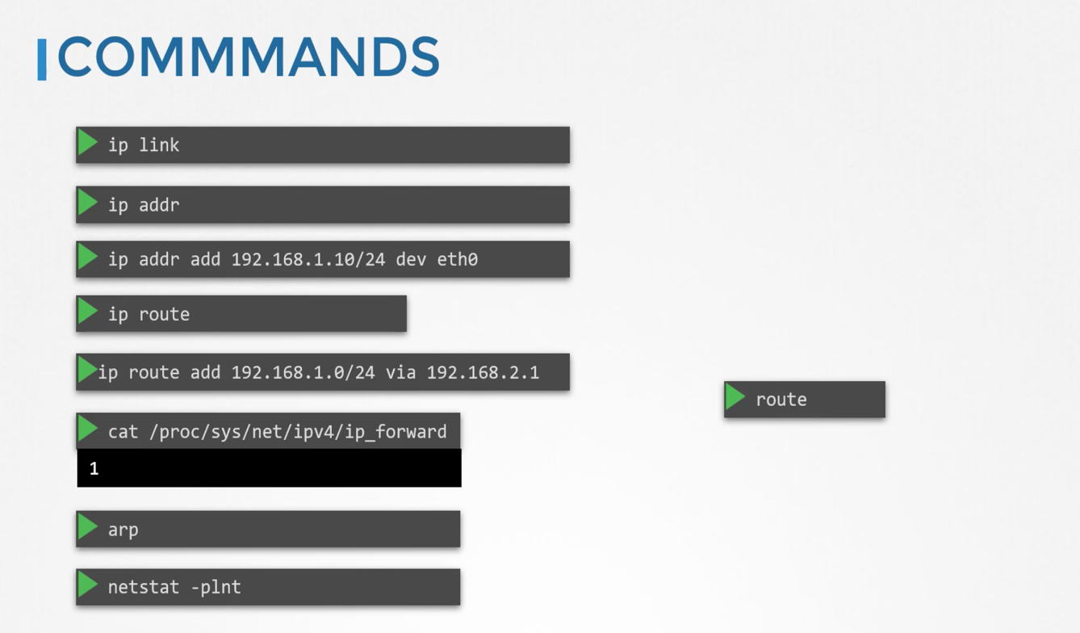

* + Getting mac address of a cluster arp <Node Name>
  + Pod Netowkring 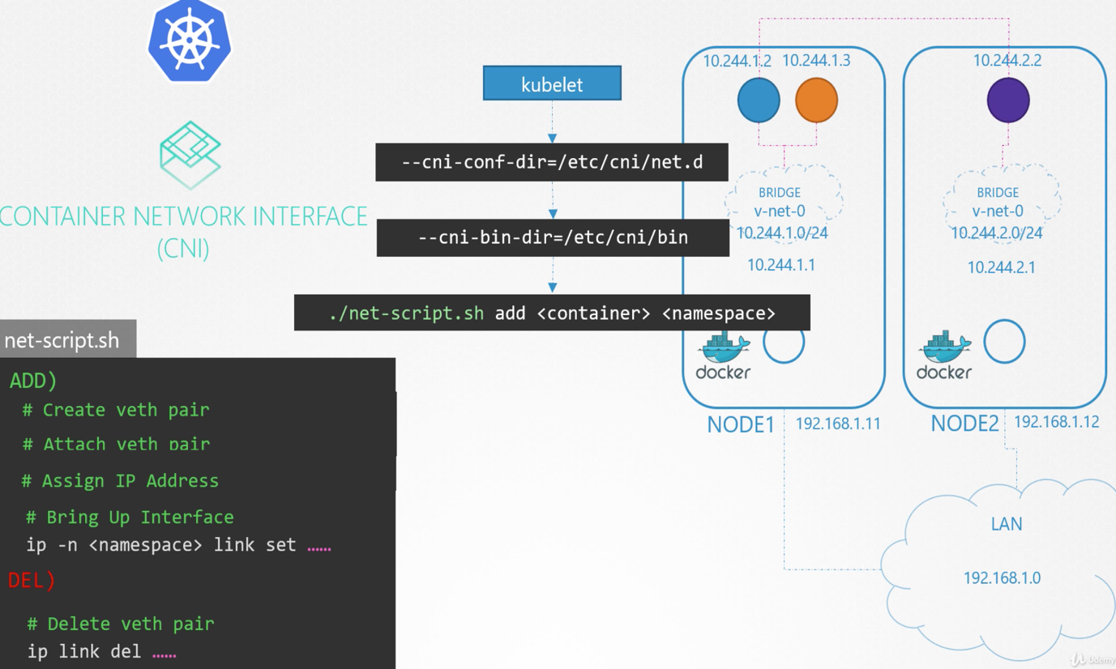
  + CNI in Kubernetes
  + Service Networking
* Ingress:
  + This can be written as :-
* **apiVersion**: networking.k8s.io/v1
* **kind**: Ingress
* **metadata**:
* **name**: ingress-resource-backend
* **spec**:
* **defaultBackend**:
* **resource**:
* **apiGroup**: k8s.example.com
* **kind**: StorageBucket
* **name**: static-assets
* **rules**:
* - **http**:
* **paths**:
* - **path**: /icons
* **pathType**: ImplementationSpecific
* **backend**:
* **resource**:
* **apiGroup**: k8s.example.com
* **kind**: StorageBucket
* **name**: icon-assets
  + kubectl get ingress --all-namespaces
* Configure Applications :-